

China English Language Education Association
December 16, 2003

Dear _____________________,

On behalf of the Organizing Committee of the 4th International Symposium on ELT in China, I would like to inform you that your article has been accepted. We formally invite you to attend our symposium and present your paper. The conference will be held from 21st-25th, May, 2004 in Beijing and will be attended by about 1,100 teachers of English from all parts of China as well as around the world.

The registration opens 8:00 am through 18 pm, 20th of May, 2004.

Please bear in mind that you have to cover your own airfare and other transport expenses, accommodation (about 15USD for a bed of a twin-share room and 30USD for a single room), food and registration (about 70USD).

If your article is co-authored, usually the first author presents the paper. If the second author is going to come and present the paper, or if both authors want to come to the conference, you must let me know ASAP via email.

Should you have any questions in regard to the conference, please don't hesitate to contact me:

Telephone: 86 10 6891 7845
Fax: 86 10 68916344
Email: celea@fltrp.com
Website: www.elt-china.org/indexe.htm

Liu Xiangdong
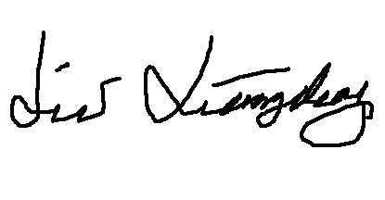
Secretary
Organizing Committee
The 4th International Symposium on ELT in China

